Searching Methods

Defination of Searching :

Searching is a process of finding the desire element from the list of elements.

There are two Popularly used searching methods:

Linear Search(Sequential Search)

Binary Search

Linear Search

Also Known as Sequential Search.

In this search technique, we start at the beginning of a list or table and search for the desired record by examining each subsequent record until either the desired record is found or the list is exhausted.

Example:
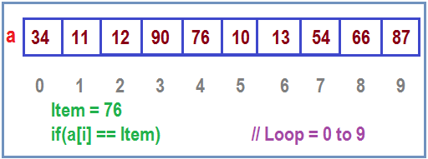

Advantage of Linear Searching

It is simple to implement

It does not require specific ordering before applying the method.

Disadvantage of Linear Searching

It is less efficient

Algorithm

Algorithm SEQSEARCH(L[], N, ITEM):

The algorithm Find an ITEM in the list L of N Elements.

Initialialize

Set Flag = 1;

Loop

Repeat step 3 for k= 0,1,2---N-1

If L[K]==ITEM then:

Set Flag = 0

Write “Search Succsesfull, Element found at Location K”

If Flag = =1 then:

Write “Search Unsuccesful, Element is not found in the List”

Finished

Exit

C Program for Linear Search: // Array Pass in a Function

void linears(int L[], int N, int item);

void main()

{

int A[]={3,4,5,6,7,8,1,12,8,33};

int item=8;

clrscr();

linears(A,10,item);

getch();

}

void linears(int L[],int N, int item)

{

int i=0,Flag=1;

for(i=0;i<N; i++)

{

if(L[i]==item)

{

printf("Item is Found at index %d",i);

Flag=0;

}

}

if(Flag==1)

printf("Item is not Found");

}

Performance:

Number of comparisions made in searching a record in a search table determines the efficiency of the technique.

On a Best Case Element found at First Position in a list. O(1)

On an Average the number of comparisons will be (n+1)/2.

The Worst Case efficiency at this algorithm in O(n).

Binary Search

Binary Search is an extremely efficient algorithm. This search technique searches the given item in minimum possible comparisons. To do the Binary Search, First we have to sort the array/ elements list.

The Logic Behind this technique is given below :

First find the middle element of the array.

Compare the mid element with an item.

There are three cases :

If it is a desired element then search is successful.

If it is less than the desired element then search only the first half of the array.

If it is greater than the desired element search in the second half of the array.

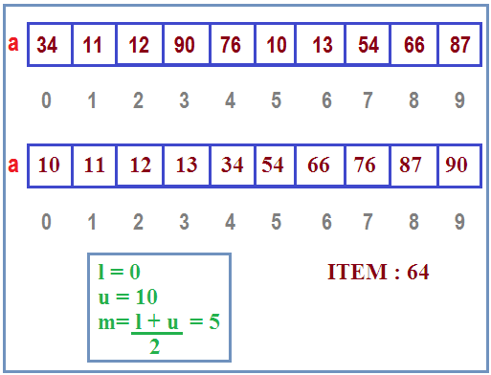

Advantage of Binary Searching

It is an efficient technique.

Disadvantage of Binary Searching

It requires specific ordering before the applying the method.

It is complex to implement.

Algorithm:

Algorithm Binary Search(L[], N, ITEM):

Find an ITEM in the sorted list L of N Elements.

[Initialize]

Set l=0 , Set u=N-1

[Loop]

Repeat step 3 and step 4 while u>=l

Set m = (l+u)/2 // get the mid element

If ITEM == L[m] then :

Write “Search Succesful, ITEM Found”

Else if ITEM>L[m] the :

Set l=m+1

Else set u=m-1 // End of loop

[Finished ] Exit

Programming Example :

void Binarys(int L[], int N, int item);

void main()

{

int A[]={3,4,5,6,7,8,11,12,18,33};

int item=8;

clrscr();

Binarys(A,10,item);

getch();

}

void Binarys(int L[],int N, int item)

{

int l=0, u=N-1, mid;

while(l<=u)

{

mid=(l+u)/2;

if(item==L[mid])

{

printf("Search Succesful at index %d",mid);

return ;

}

else if(item>L[mid])

{

l=mid+1;

}

else

{

u=mid-1;

}

}

printf("Search Unsuccesful");

}

Searching Method | Time Complexity
Linear Search | O(n)
Binary Search | O(nlogn) : 10 when n=1000

